Grove - 4-Digit Display

|  |
| --- |
| **Contents**   [[hide](javascript:toggleToc())]   * [1 Introduction](http://www.seeedstudio.com/wiki/Grove_-_4-Digit_Display#Introduction) * [2 Features](http://www.seeedstudio.com/wiki/Grove_-_4-Digit_Display#Features) * [3 Application Ideas](http://www.seeedstudio.com/wiki/Grove_-_4-Digit_Display#Application_Ideas) * [4 Specifications](http://www.seeedstudio.com/wiki/Grove_-_4-Digit_Display#Specifications) * [5 Interface Function](http://www.seeedstudio.com/wiki/Grove_-_4-Digit_Display#Interface_Function) * [6 Usage](http://www.seeedstudio.com/wiki/Grove_-_4-Digit_Display#Usage) * [7 Resources](http://www.seeedstudio.com/wiki/Grove_-_4-Digit_Display#Resources) * [8 Support](http://www.seeedstudio.com/wiki/Grove_-_4-Digit_Display#Support) |

Introduction

Grove - 4 Digit Display module is usually a 12 pin module. In this module, we utilize a TM1637 to scale down the controlling pins into 2 Grove pins. It only takes 2 digital pins of Arduino or Seeeduino to control the content, even the luminance of this display. For projects that require of alpha-numeric display, this can be a nice choice.

[Model: LED05291P](http://www.seeedstudio.com/depot/grove-4digital-display-p-1198.html?cPath=156_157)

[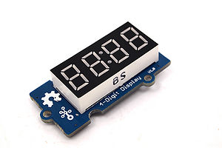](http://www.seeedstudio.com/wiki/File:Grove_-_4_digit_display.jpg)

Features

* 4 digit red alpha-numeric display
* Grove compatible interface (3.3V/5V)
* 8 adjustable luminance levels

Application Ideas

* Time display
* Stopwatch
* Sensors’ input display

Specifications

|  |  |  |  |  |
| --- | --- | --- | --- | --- |
| **Item** | **Min** | **Typical** | **Max** | **Unit** |
| **Voltage** | 3.3 | 5.0 | 5.5 | VDC |
| **Current** | 0.2 | 27 | 80 | mA |
| **Dimension** | 42x24x14 | | | mm |
| **Net Weight** | 7±1 | | | g |

Interface Function

[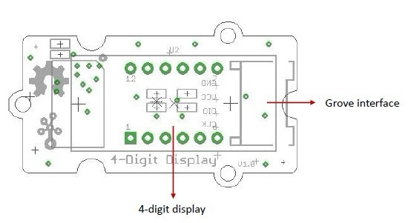](http://www.seeedstudio.com/wiki/File:4-digit_display_interface.jpg)  
**Grove interface** - Can be connected to digital port on Grove - Base Shield.

**4 - digit display** - Common anode digital tube.

**Pin definition:** CLK DIO VCC GND

Usage

The module use a LED drive chip - TM1637 for controlling the display contents，even can change the luminance. Here we drive it to diaplay clock.   
1. Connect the Grove socket marked "IN" on the LED Strip Driver and digital port 2 of the [Grove - Base Shield](http://www.seeedstudio.com/depot/grove-base-shield-p-754.html?cPath=132_134) with a Grove cable. You can change to the digital port as you like. But don't forget to change the port number in the definition of the demo code at the same time.  
2. Plug onto Arduino/Seeeduino or plug [Grove - Mega Shield](http://www.seeedstudio.com/depot/grove-mega-shield-p-934.html?cPath=132_134) onto Arduino Mega.   
Seeeduino and Grove - 4-digit display:  
[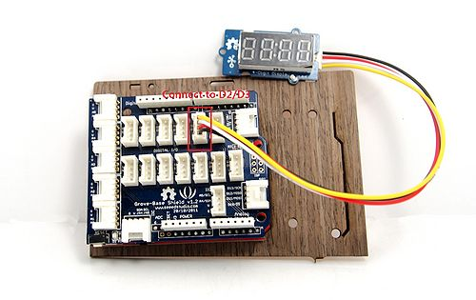](http://www.seeedstudio.com/wiki/File:Seeeduino_and_4-digit_display.jpg)  
Arduino Mega and Grove - 4-digit display:  
[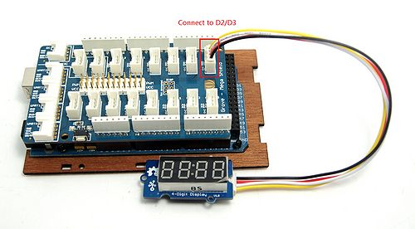](http://www.seeedstudio.com/wiki/File:Arduino_Mega_and_4-digit_display.jpg)  
3. Connect Arduino/Seeeduino to PC via a USB cable.  
4. Download [the 4-Digit Display library](http://www.seeedstudio.com/wiki/File:DigitalTube.zip) and [TimerOne library](https://code.google.com/p/arduino-timerone/downloads/detail?name=TimerOne-v9.zip&can=2&q=). Unzip and put them in the libraries file of Arduino IDE by the path: ..\arduino-1.0\libraries.

5. Restart the Arduino IDE, open one demo code you like, for example ClockDisplay directly by the path:File -> Example ->DigitalTube->ClockDisplay.  
[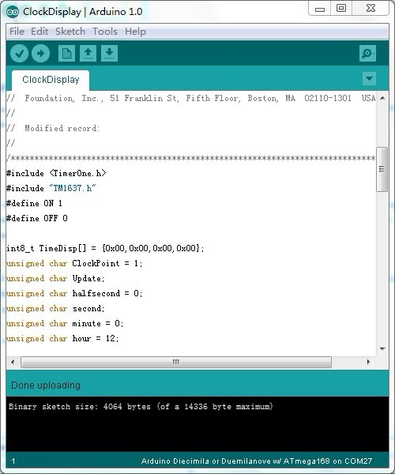](http://www.seeedstudio.com/wiki/File:Open_ClockDisplay.ino.jpg)  
6. Upload the demo code and the clock is ticking now.Please click [here](http://www.seeedstudio.com/wiki/Upload_Code) if you do not know how to upload.

You can see this:   
[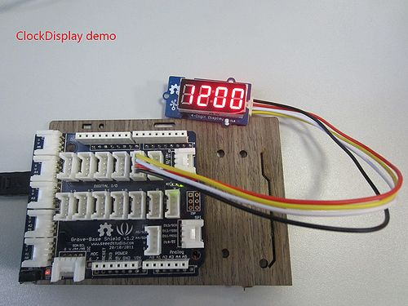](http://www.seeedstudio.com/wiki/File:Display_the_clock.jpg)

Resources

* [Grove - 4-Digit Display V1.0 eagle files](http://www.seeedstudio.com/wiki/File:Grove_-_4-Digit_Display_V1.0_eagle_files.zip)
* [Schematic in PDF](http://www.seeedstudio.com/wiki/images/4/4f/Grove_4-Digit_Display_V1.0.pdf)
* [4-Digit Display library](http://www.seeedstudio.com/wiki/File:DigitalTube.zip)
* [TimerOne library](https://code.google.com/p/arduino-timerone/downloads/detail?name=TimerOne-v9.zip&can=2&q=)

Support

Let us know if you have any question by dropping it on the product page or [forum](http://www.seeedstudio.com/forum) . Got a brilliant idea? Don't hesitate to share it on the [wish](http://wish.seeedstudio.com/)  page with the community.